Company Database
Project report

-Class: Computer Science & Technology 2022
-Student ID: 20010026
-name: 阿吉兹 - Aziz
-Date: 01/12/2022

catalog
1 System plan and analysis 3
1.1system plan 3
1.2 system analysis 3
2 System design 4
2.1 system architecture design 4
2.2 system functional structure design and work flow chart 5
2.3 database design 6
3 Instruction 10
2.1 overview of the system 10
2.2 system function 10
4 Project development thoughts and course learning suggestions 11

1 system analysis

1.1system plan

Companies all over the world have complicated structures and that’s why I made this company database. My project is like a template that you can use for any type of company.

1.2 system analysis

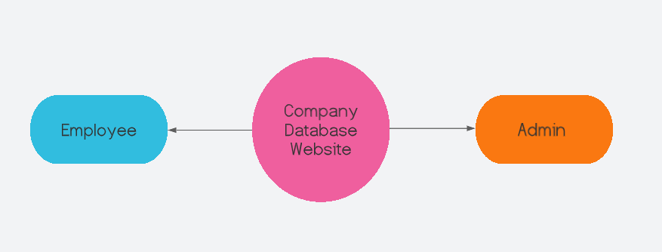

Figure 1.1 Data flow diagram of Company Database Website (level 0)

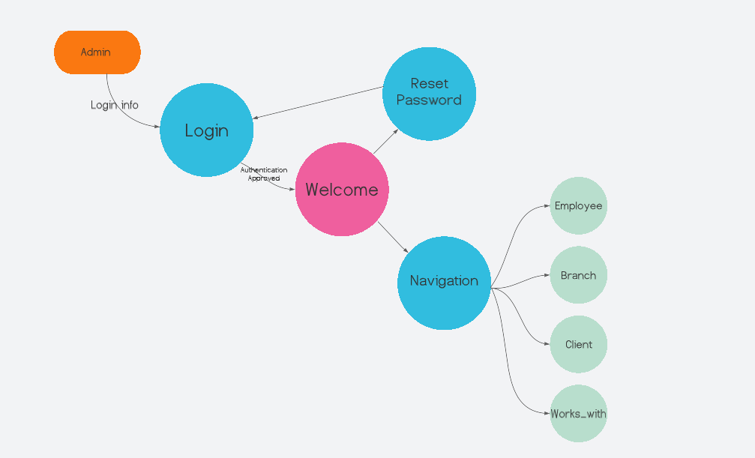

Figure 1.2 Data flow diagram of Company Database Website (level 1 - Admin)

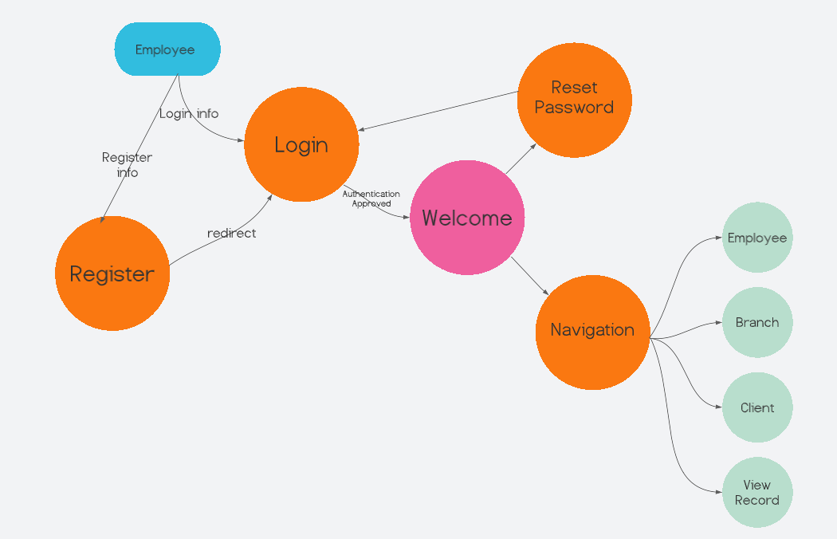

Figure 1.3 Data flow diagram of Company Database Website (level 1 - Employee)
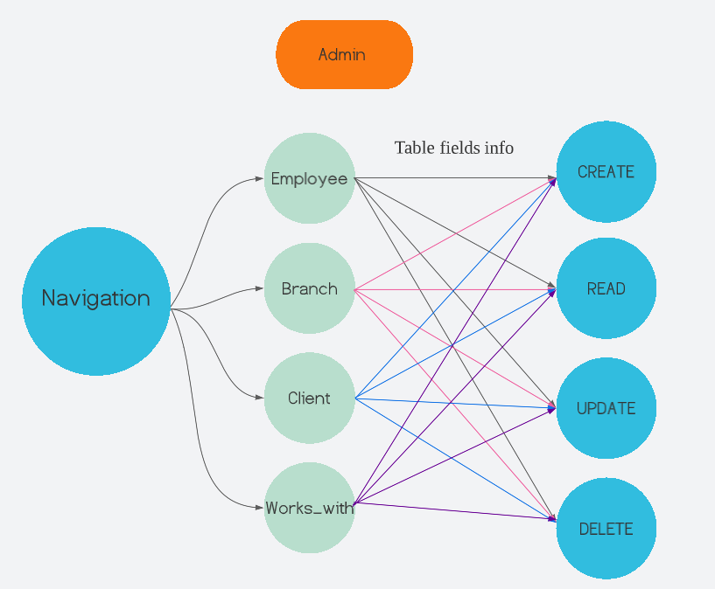

Figure 1.4 Data flow diagram of Company Database Website (level 2 - Admin)

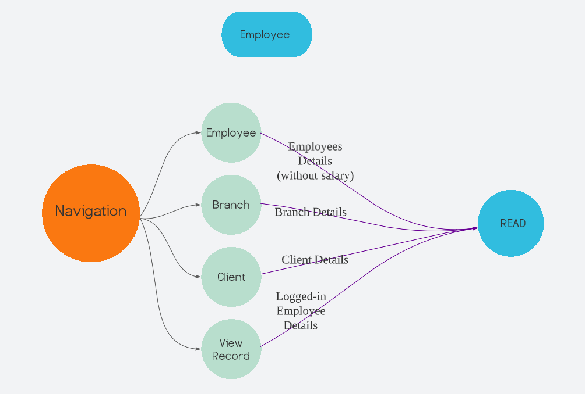

Figure 1.5 Data flow diagram of Company Database Website (level 2 - Employee)

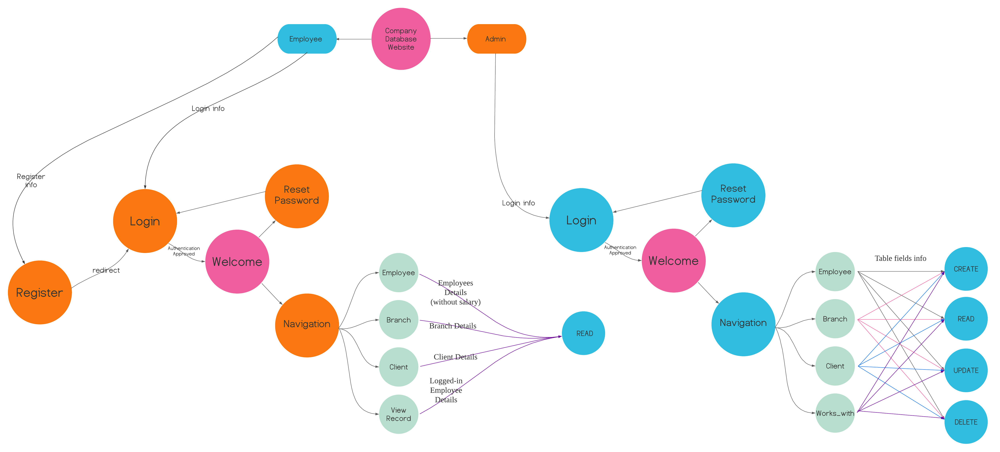
Figure 1.6 Data flow diagram of Company Database Website

2 system design

2.1 system architecture
The system adopts B/S architecture, I choose WAMP server to host a local host on my machine. In this server I used php for the back-end. HTML, CSS (with bootstrap framework) for the front-end. And for the database I used MYSQL.
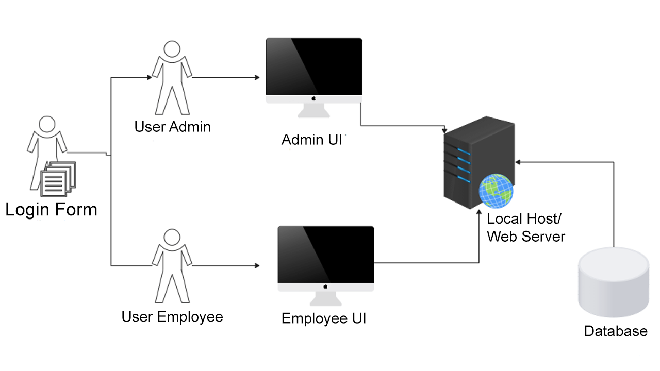

Figure 2 System Structure of Company Database Website

2.2 system functional structure and flow chart
According to the business requirements and data flow diagram obtained from the requirements analysis, the functional structure diagram of the system can be defined as shown in Figure 3.

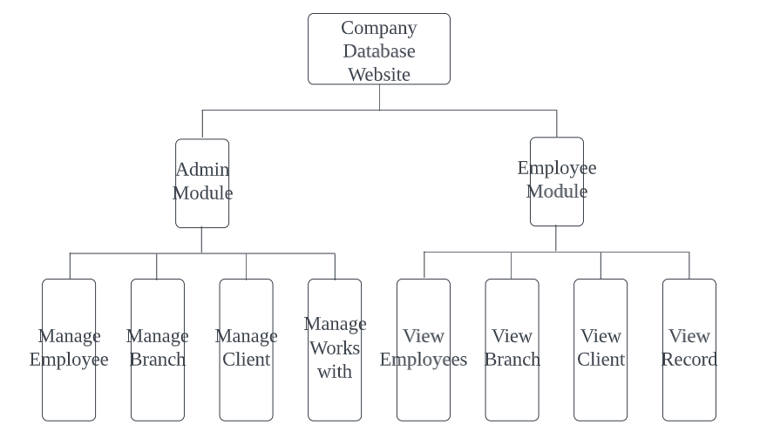
Figure 3 Functional Structure of Company Database Website

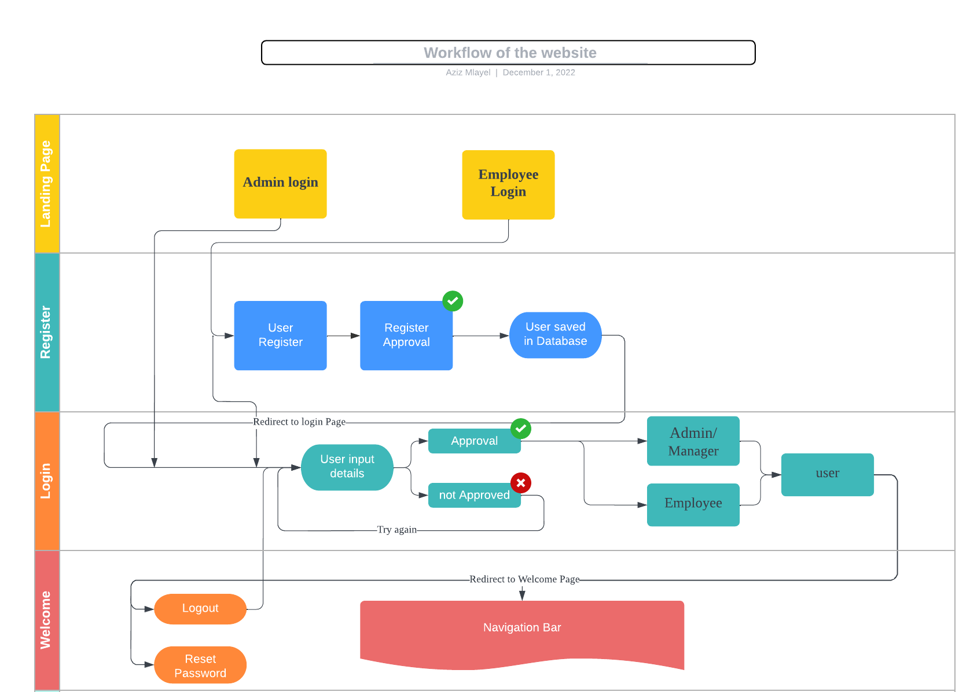
Figure 4.1 Workflow of the 4 first Modules
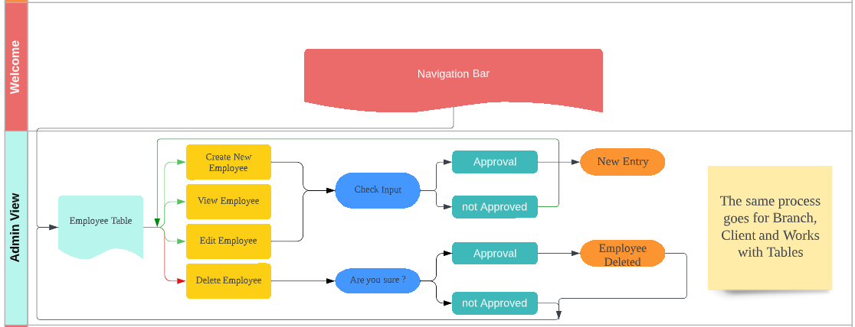
Figure 4.2 Workflow of the Admin view Module

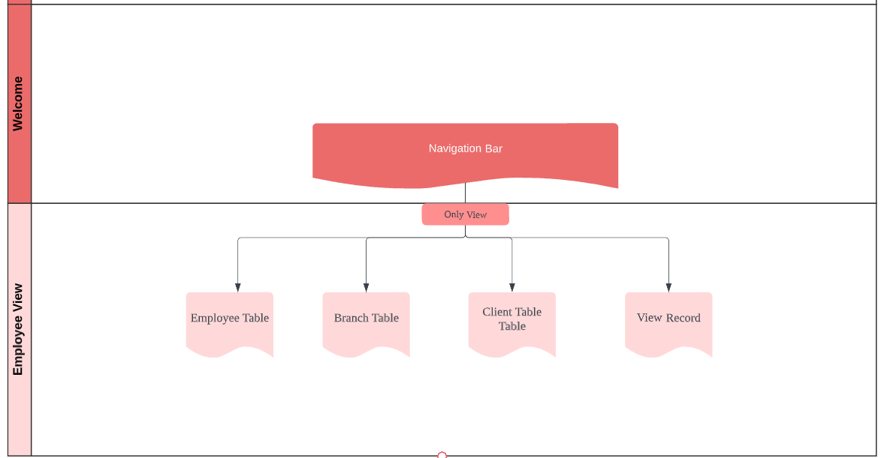
Figure 4.2 Workflow of the Employee view Module

2.3 database design
（1）Database conceptual design
The system mainly involves mainly on the Employees. There are many relationships between the employees and other tables. The E-R diagram showcases these relationships, as shown in Figure 4.
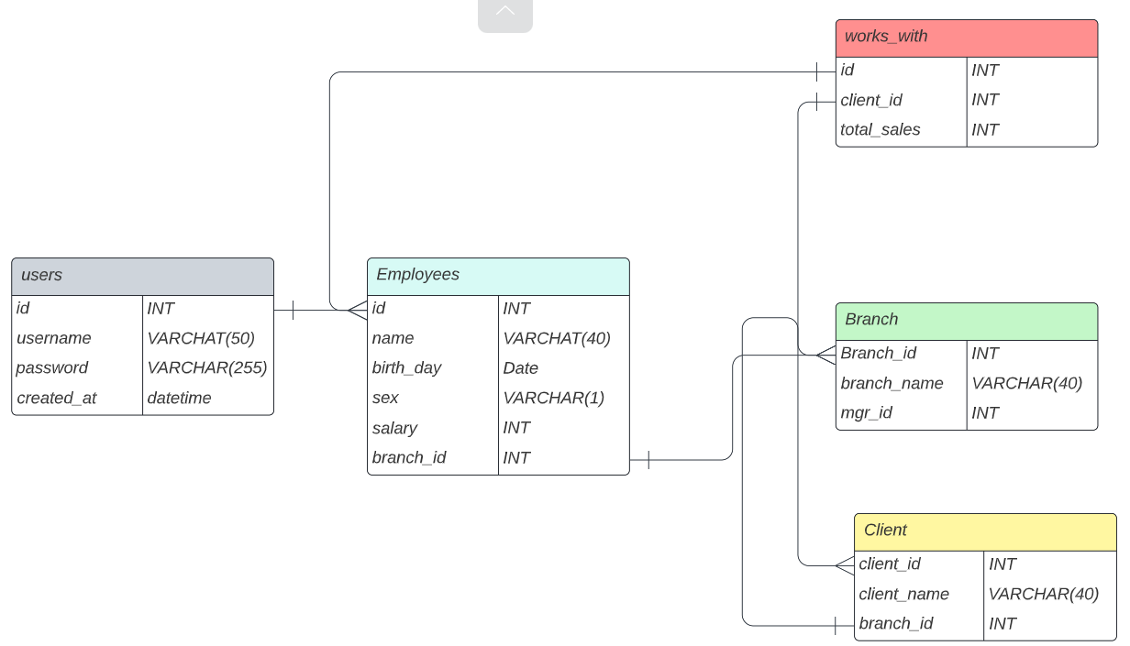
Figure 5 E-R Diagram Company Database

（2）Physical design of database
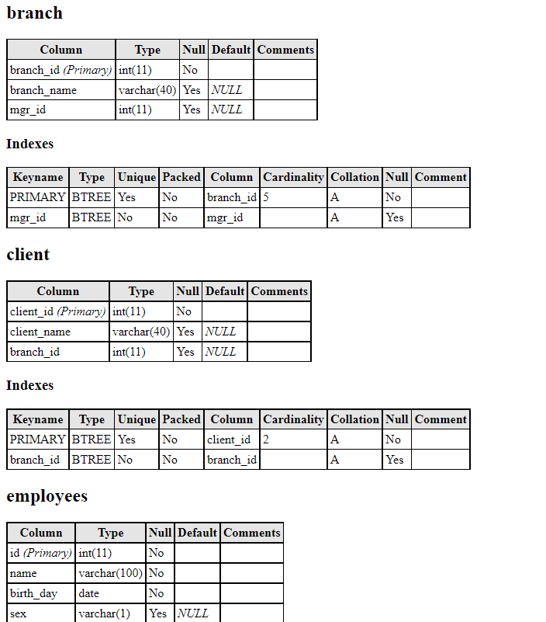
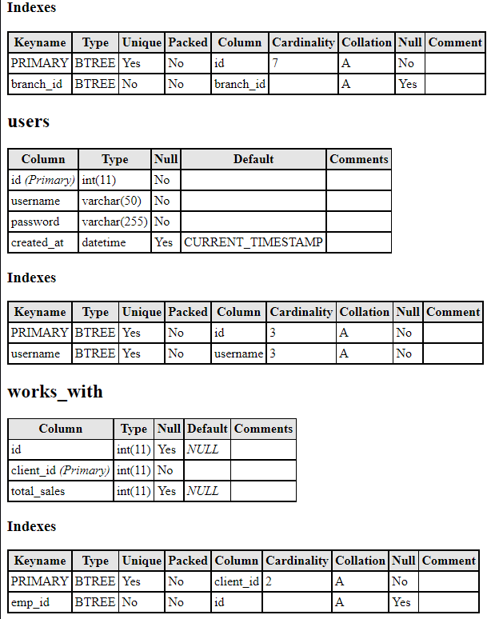

3 instructions

3.1 overview

The system adopts B/S structure, and users can access the website through browser. For now, is the website is on local host but it can be hosted online.

3.2 system function

3.2.1 Landing Page
In this page you can choose your login type (Admin or Employee)
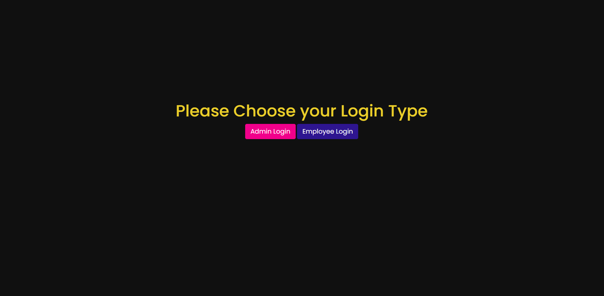
Figure3.1 Landingpage.html

3.2.2 Login Page

3.2.2 Login Page

3.2.2.1 Admin Login
Page for the admin to login
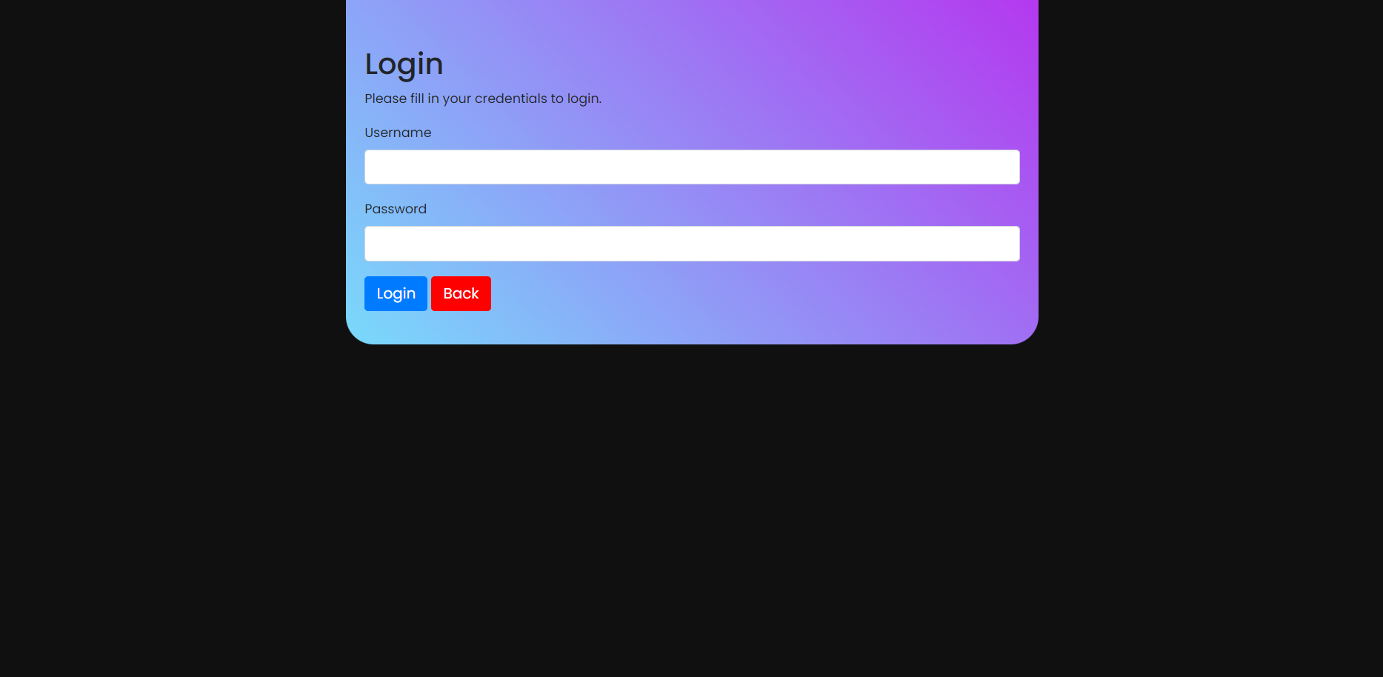
Figure3.2 login.php

3.2.2.1 Employee Login
In this page you can choose 2 options either to login with your already existing account or create a new account.
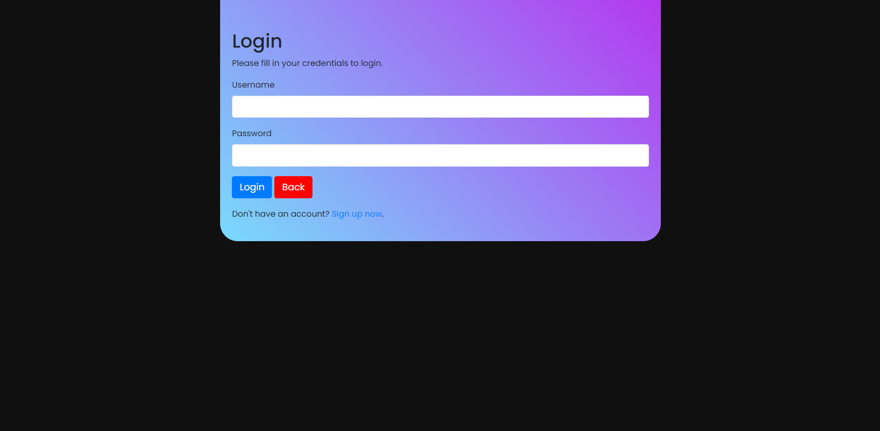
Figure3.3 loginE.php

3.2.2.2 Employee Register
When you choose to register in this page you need to input a username (with validation of the input in the backend)
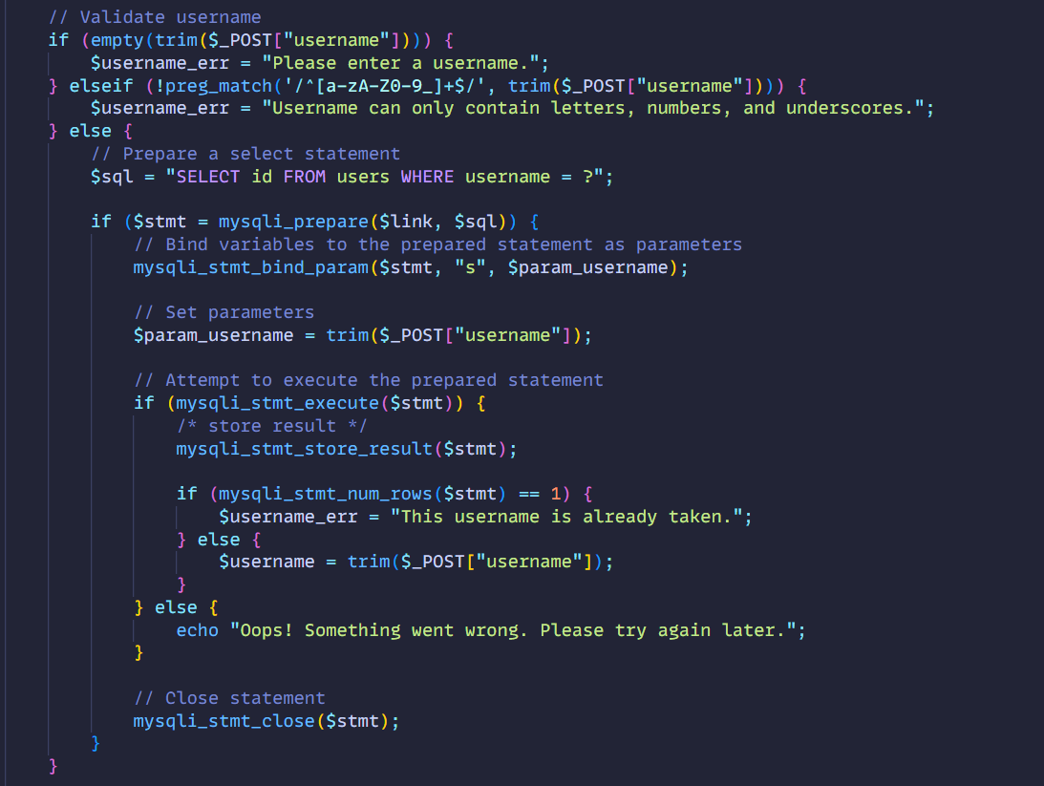
After the username validation. The username is put inside the database in the users table. And then there is the password. For the password you need to input at least 6 characters. When the password is input in the database it goes through some encryption.
-Bcrypt Encryption
So to protect the users from hackers and the database in general. I choose to use an encryption in the password and use the password hash function from the php. I read the documentation of the php and the easiest and most effective one to implement is the PASSWORD DEFAULT which uses bcrypt encryption.
Bcryption stands for blow fish encryption and it is a strong algorithm to hash the password. For example the user types the word hello. We take it in the backend and make go through the algoirthm of hashing and then store it in the database. Lets see the example of the admin login.
The password that we assigned to admin is actually a very weak password which: “azerty” it gets into the password hashing function here:

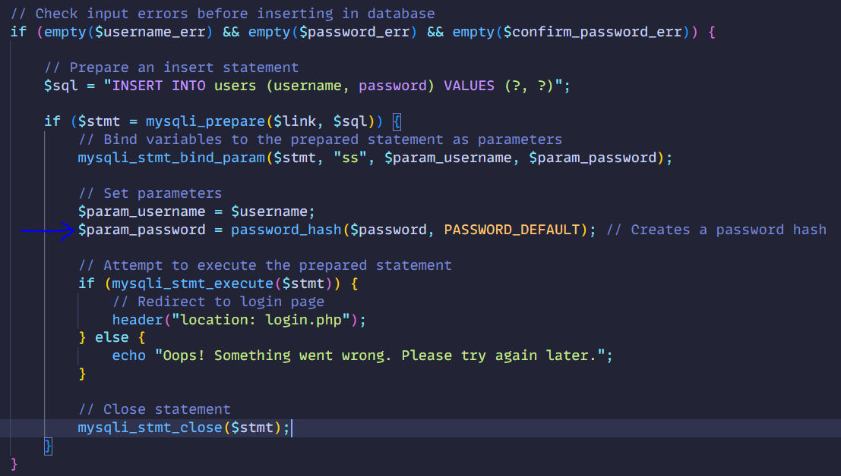
And then we store it into the database. The good thing about Bcrypt is there is no way to go back from the encrypted password to the original one. Because it goes through a lot of process. Now to verify the password when we are logging in is simple. We just hash the input of the user and compare it to the hash that we have in the database. If it the same then login is authorized.

3.2.3 Admin Welcome Page
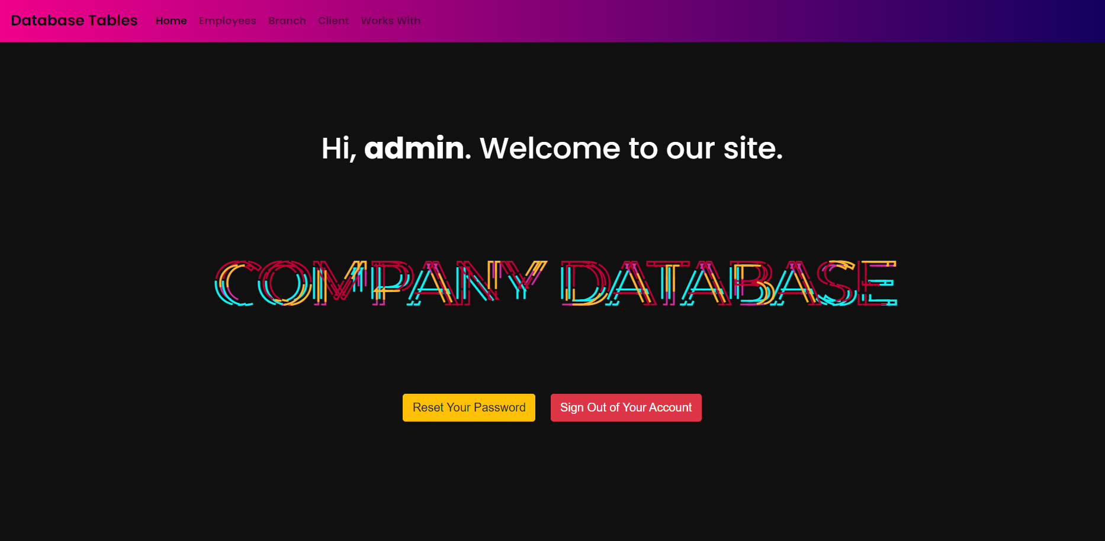
Here you can find a bunch of buttons with different functions that I explained in previous diagrams.

3.2.4 Employee Table Admin View

The admin can Create, Read, Update and delete any entry in the table
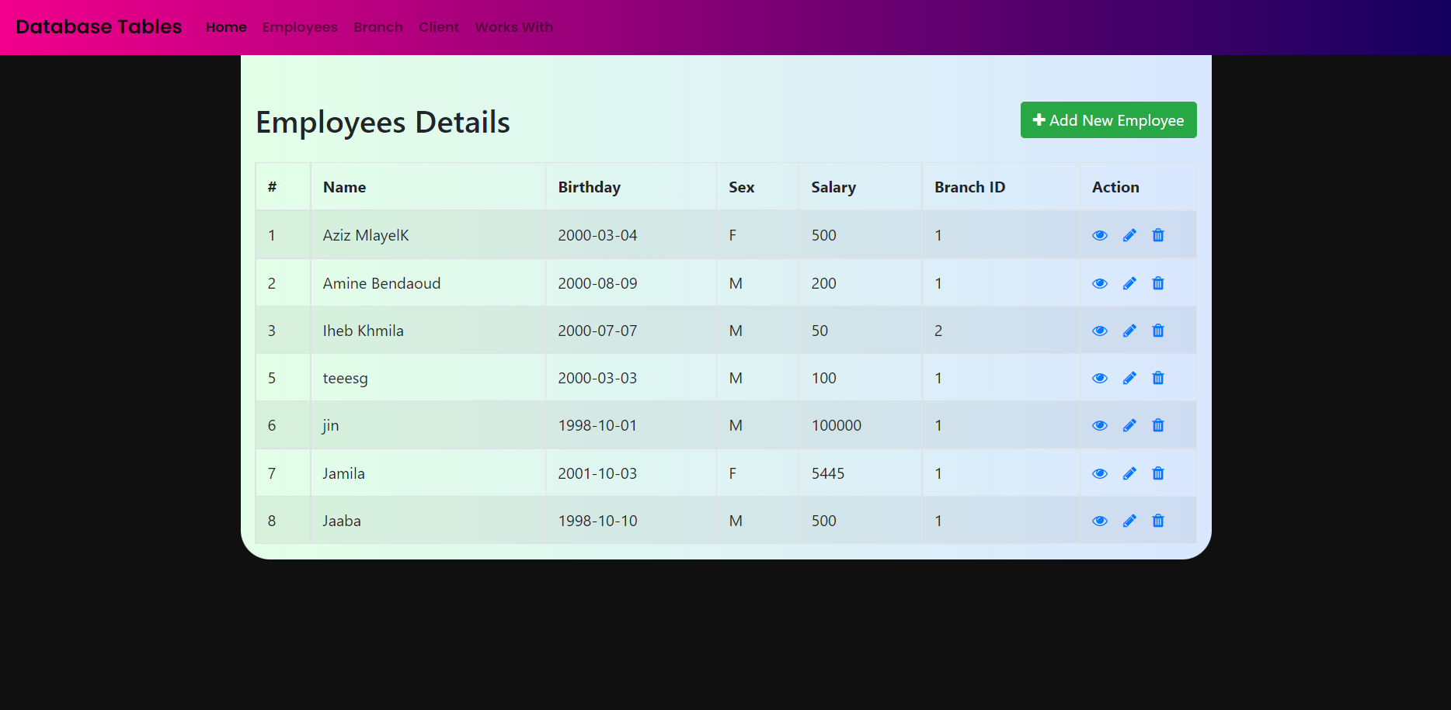

3.2.4.1 Validation of Entry
For each entry to the database for create button or update button there is a validation so there is no sql injection or wrong entry.
For example:
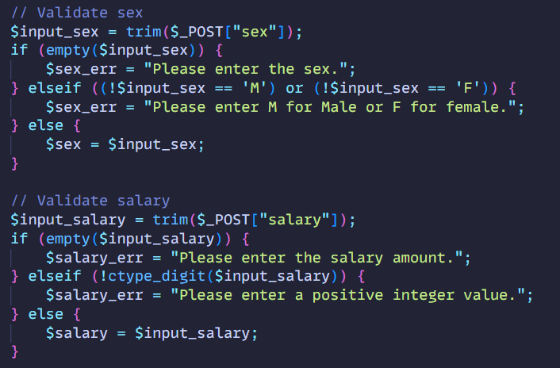

Example of error
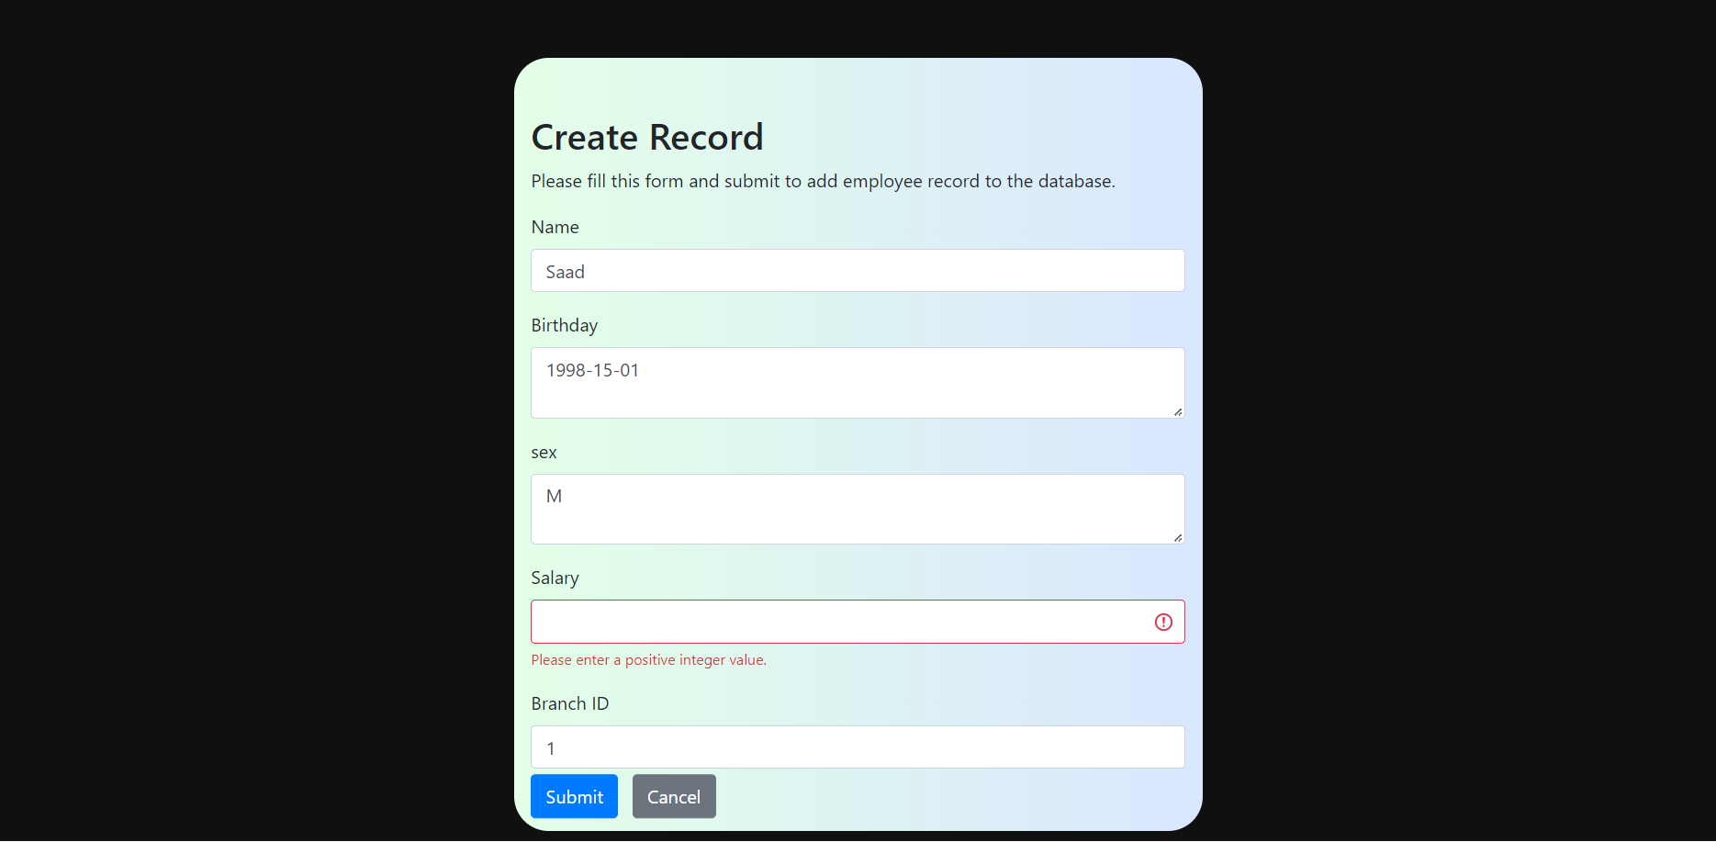
Code for each table view can be found in index.php documents. Basically we have a config.php file that connects our database to local host and then we use php commands to get the variables from the table and showacase it with HTML and Css and bootstrap.
Everything in this project is linked together through all of these languages.

3.2.3 Employee View
The employee that logs in can only view the tables, he can’t do any actions of the admin. The only thing that he can do is read his own record. We achieve this by getting the login session id from the users table in the database and since the id is linked to the id in the employees table we can the record from there. This is the code that showcases it.
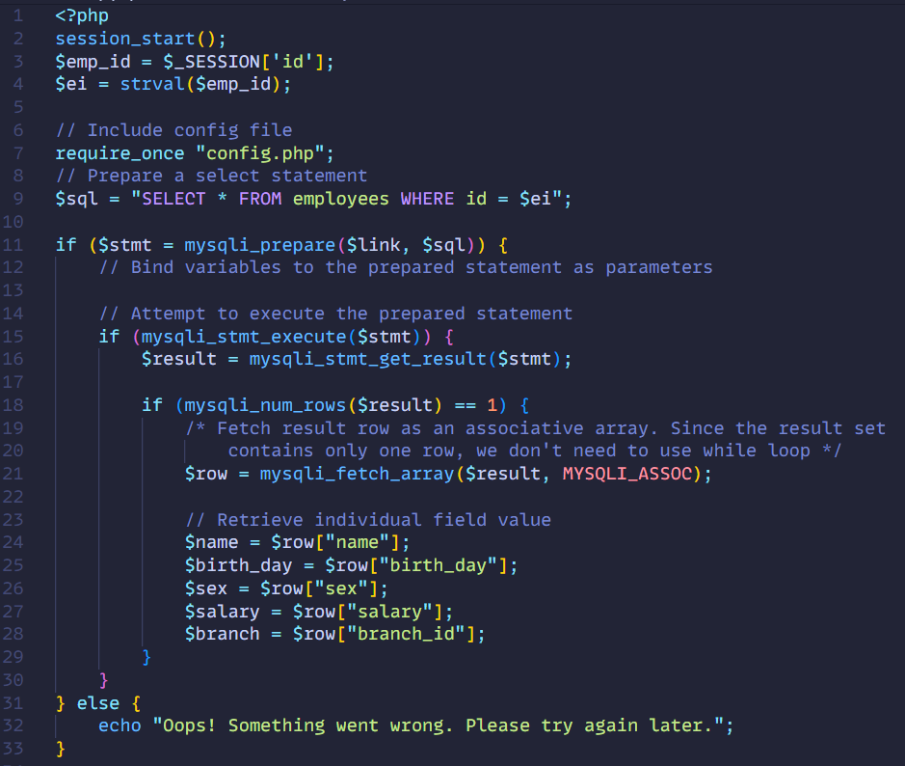
Example of the employee Iheb_Khmila
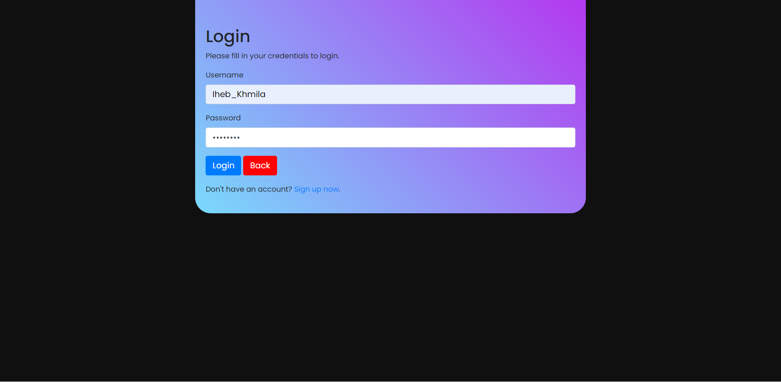
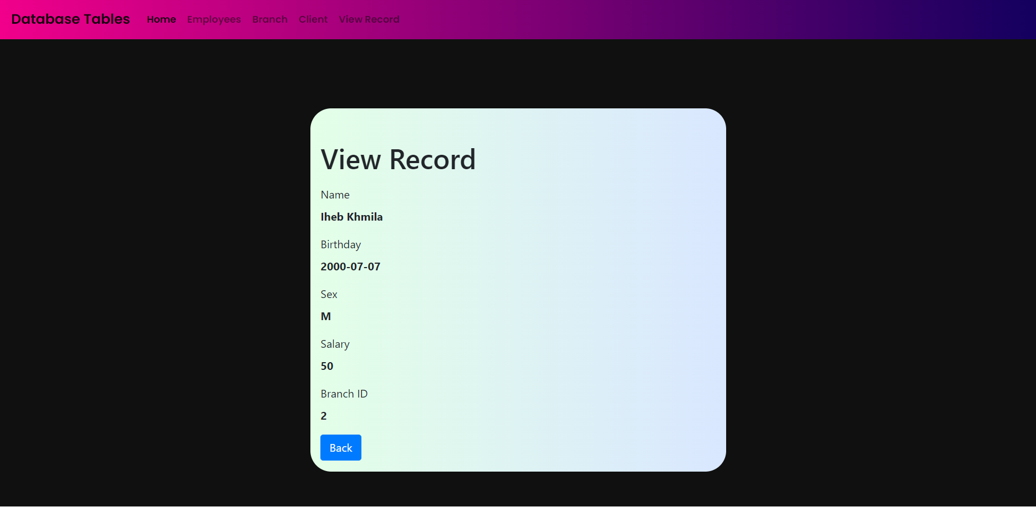
As you can see here the record shows all his details including his salary. Important feature: when employees login they can only see their own salary. The salary column is hidden for Employee view.

4 Project development gains and course feedback

4.1 Main Technologies
Programming Languages:
Php: is a general-purpose scripting language geared toward web development. I used to link my database to website and run php commands to run SQL commands
HTML (Hyper Text Markup Language): standard markup language for documents designed to be displayed in a web browser. I used it as UI for the queries and the functions from the SQL code
CSS: Cascading Style Sheets is a style sheet language used for describing the presentation of a document written in a markup language such as HTML. I used to make the cool designs in the website
Bootstrap Framework: Bootstrap is a free and open-source CSS framework directed at responsive, mobile-first front-end web development. The standard HTML elements don’t look good. So with the help of Bootstrap framework for CSS I have good looking design for the elements of my website.
SQL: Structured Query Language, abbreviated as SQL, is a domain-specific language used in programming and designed for managing data held in a relational database management system. I used it to create the database for the Company.
IDE:
Visual Studio: it is one the best IDE nowadays because it has many features and the UI is amazing and customizable. You can write in any language and it will automatically highlight the keywords. It also has some very effective extensions like code snippets that basically gives you the template for HTML elements for example when you write “p” it automatically fills it in and writes <p></p>
Server:
WAMP: WampServer is a Windows web development environment. It allows you to create web applications with Apache2, PHP and a MySQL database. Alongside, PhpMyAdmin allows you to manage easily your databases.
Database Management:
PhpMyAdmin: phpMyAdmin is a free and open-source administration tool for MySQL. This made managing the database so clear and so easy.

4.2 Please summarize your thoughts on the project and put forward your suggestions on the course study so that we can continue to improve.
This is the first time I make functional website with database and different login and authentication. To be honest this was the most challenging project I have ever done in my computer science major because I had to write in 4 different languages that I didn’t have much experience with. But I learned a lot of things in the past month and I’m going to keep learning about these languages.

